**BIOGRAPHY**

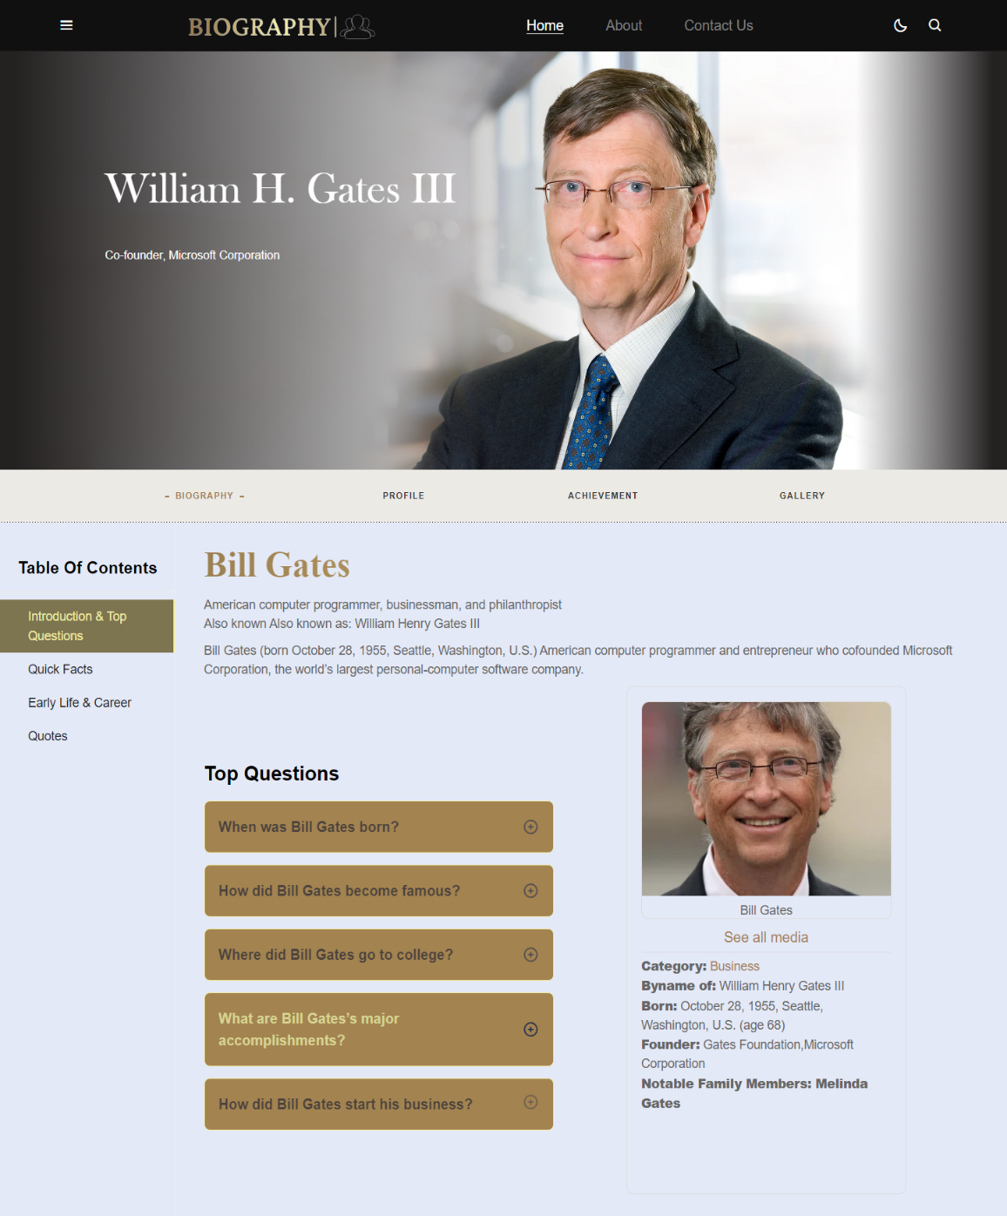

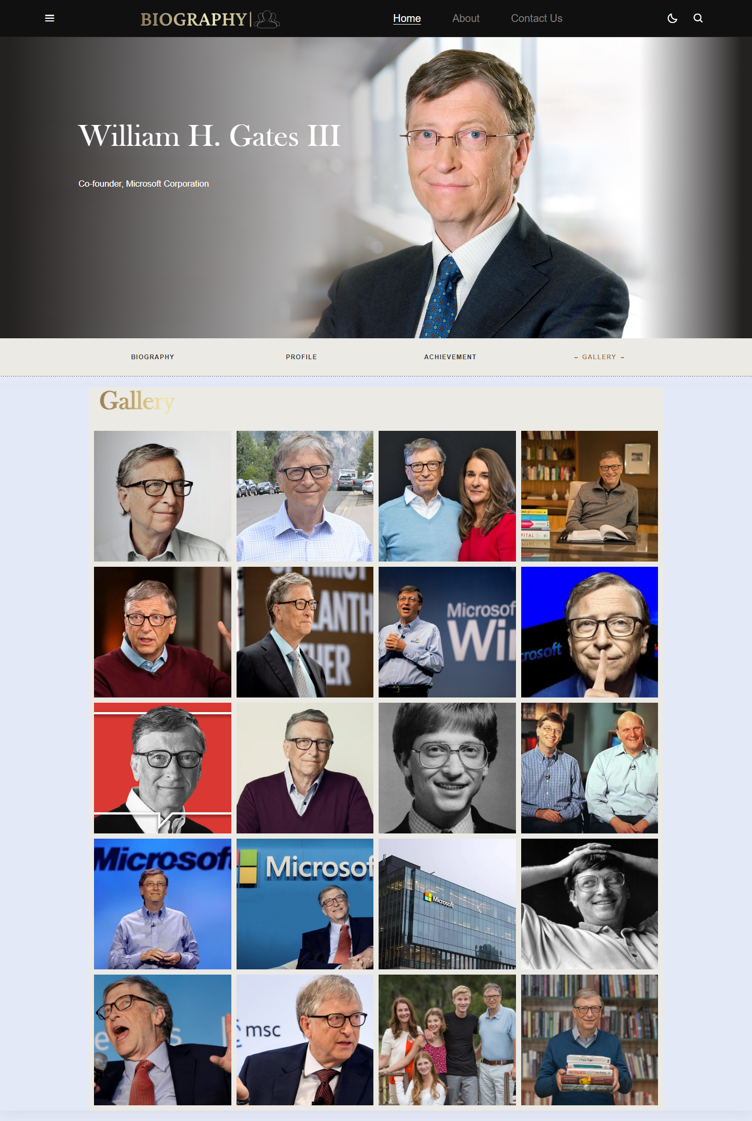

|  |  |  |
| --- | --- | --- |
| **Supervisor** | SIR Muhammad Ikram | |
| **Batch** | 2309E3 | |
| **Group** | **C** | |
| **Serial No.** | **Enrollment Number** | **Student Name** |
| 1. | *Student1511010* | Shakir Muhammad |
| 2. | *Student1512095* | Ahmad |
| 3. | *Student1510202* | Muzammil Shafiq |
| 4. | *Student1509187* | Shayan |

# Problem Statement:

A biography is a detailed description of a person's life. It involves more than just the basic facts like education, work, relationships, and death; it portrays a person's experience of these life events. Unlike a profile or [curriculum vitae](https://en.wikipedia.org/wiki/Curriculum_vitae) ([résumé](https://en.wikipedia.org/wiki/R%C3%A9sum%C3%A9)), a biography presents a subject's life story, highlighting various aspects of their life, including intimate details of experience, and may include an analysis of the subject's personality.

You need to develop a biography of any **Nobel Prize winner** in **science genre**.

You are supposed to create a Single-Page-Application and responsive Website for them with the below mentioned requirement specifications.

The website is to be developed for the Windows Platform using HTML5, JSON, Angular JS, JavaScript and Geolocation. The site should work well in all leading browsers including Chrome, IE, Firefox etc.

# Functional Requirement Specification:

The Web site is to be created based on the following requirements.

The portal will be designed as a Single-Page-Application and responsive Website with a set of pages and menus that represent choice of activities to be performed. The pages, menus, and other visual elements must be designed in a visually appealing manner with attractive fonts, colors, and animations.

All of these should also be laid out in a responsive manner

The Web site is to be created based on the following requirements.

1. The Top of the Page should be presented with a suitable logo and various images of respective personality.
2. The site must be divided into various sections viz, Biography, Research, Awards and honors, Selected Works, References etc.
3. The site should include the complete personal details about the respective person
4. User should also be able to get the glimpse of education and carrier.
5. There should be carrier graph and struggle of the person
6. One should be able to get to know the complete details about the achievements.
7. There should also be a section that includes the details specifying research/experiment for which Nobel Prize was awarded.
8. There should be a section where one can get to know the available books related to him/her
9. Gallery with various images of the personality should be added.
10. Site map should be provided in the webpage.

Over and above this, the portal should implement the following functionalities:

* Display a continuous scrolling ticker at the bottom of the page with current date, time, and location (hint: Use geolocation features of HTML5).
* Display a visitor count at the top right corner of the page beside a logo image.
* The menu options should change color on hover and also after clicking.
* Fade in and fade out options can be used for the menus.

**Acknowledgment:**

We are thrilled to embark on the journey of crafting a cutting-edge news platform for Biography, a leading news agency dedicated to delivering accurate and timely information to its audience. Our team's proficiency in HTML5, JSON, React JS, JavaScript, and dynamic content presentation, coupled with a steadfast commitment to ensuring compatibility across various devices and browsers, assures the creation of an engaging and accessible website. Our aim is to not only simplify the process of accessing news but also to revolutionize the way users interact with information, offering a seamless experience that adapts to modern browsing habits. We eagerly anticipate collaborating with DNBC to transform this vision into reality and provide audiences worldwide with a contemporary, intuitive, and informative news hub.

**Synopsis:**

**Introduction:**

Addressing the growing need for a streamlined and accessible news consumption experience, this project is dedicated to developing a responsive website for DNBC, a leading news agency. With a focus on delivering accurate and up-to-date information, DNBC aims to redefine how users engage with news in today's fast-paced world.

**User Interface:**

At the core of this project is the creation of an intuitive, visually compelling user interface. Harnessing the power of HTML5, JSON, JavaScript, and content flexibility, our team will craft a platform that ensures seamless access to news across devices and browsers. The interface will prioritize user engagement, offering dynamic content presentation and adaptability to modern browsing habits, thereby enhancing the overall news-consuming experience.

**Conclusion:**

This initiative marks a pivotal moment for DNBC and the realm of news dissemination. By embracing cutting-edge technology and a user-centric design philosophy, our goal is to elevate DNBC's position as a go-to news source. Through this project, we aspire to empower audiences worldwide with a contemporary, informative, and effortlessly accessible news platform. This commitment to excellence drives us, and we eagerly anticipate delivering a website that not only meets but surpasses the expectations of DNBC and its audience.

**Hero Section:**

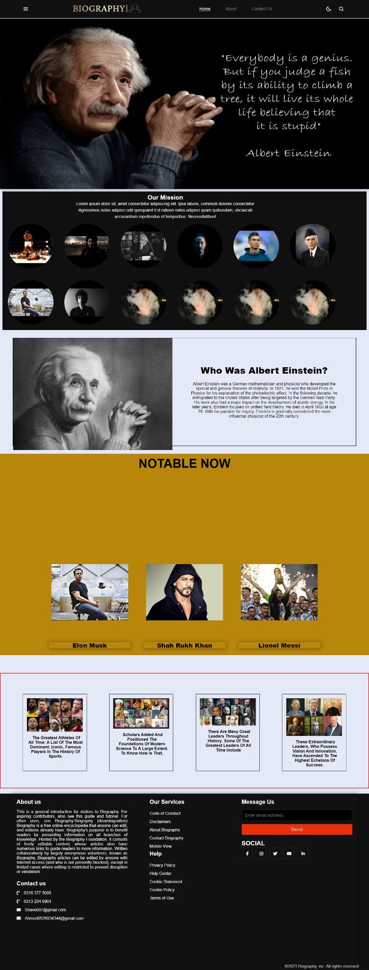

**Navbar:**

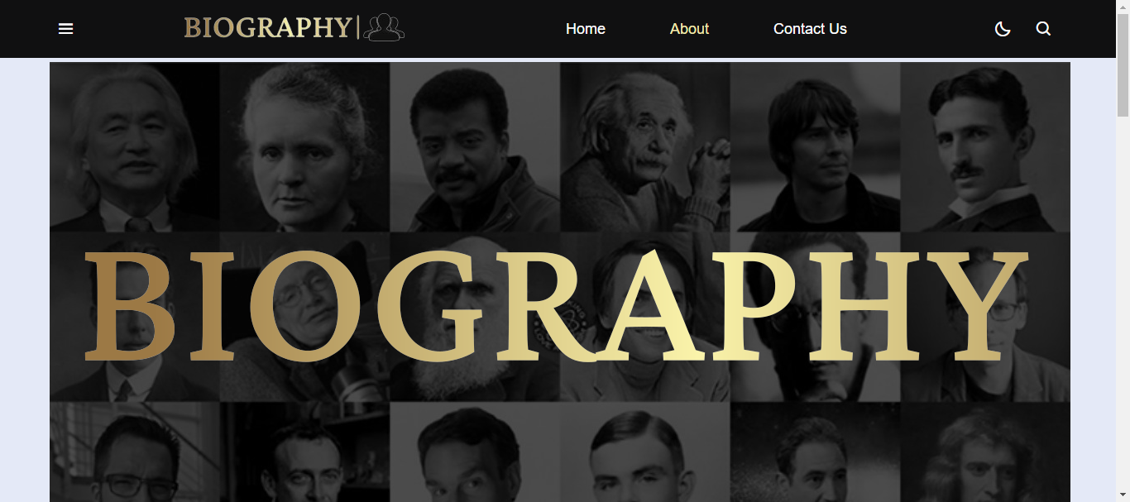

There are seven essentials listed here, and you will be redirected to all the pages, which are further classified as:

* **HOME:** Explore the latest headlines and top stories.
* **Biography page:** Information about respective person, about their struggle, achievements, and profile, and watch their gallery
* **BUSINESS:** Stay updated on financial news, market trends, and industry insights.
* **Scientists**: Get to know about Scientists
* **Athletes:** Get to know about greatest athletes
* **ABOUT US:** Learn more about Biography - our mission, values, and team.
* **CONTACT:** Reach out to us for inquiries, feedback, or collaborations.

**Contact Us:**

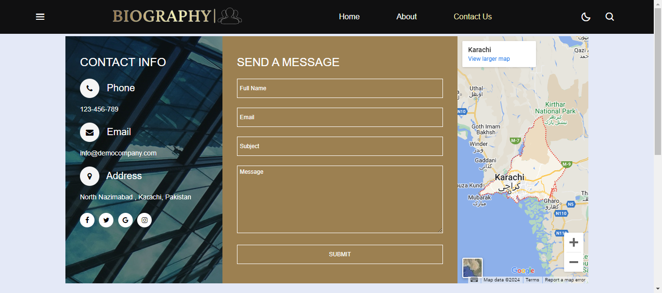

**About US:**

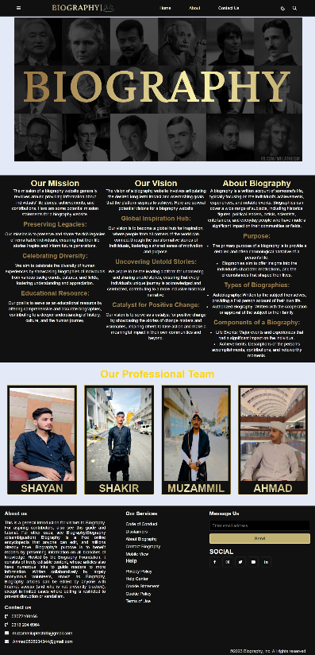

Welcome to 'Today in World' by Biography, your daily gateway to the latest global events and significant happenings shaping our world. Here, we curate a comprehensive overview of the day's most impactful news, covering a spectrum of topics ranging from politics, economics, technology, to social and cultural developments. Dive into concise yet insightful updates, breaking stories, and in-depth analyses that offer a nuanced understanding of the dynamic landscape we live in. 'Today in World' is your go-to resource for staying informed and connected to the pulse of current affairs, ensuring you're abreast of the pivotal moments unfolding worldwide.

**Footer:** 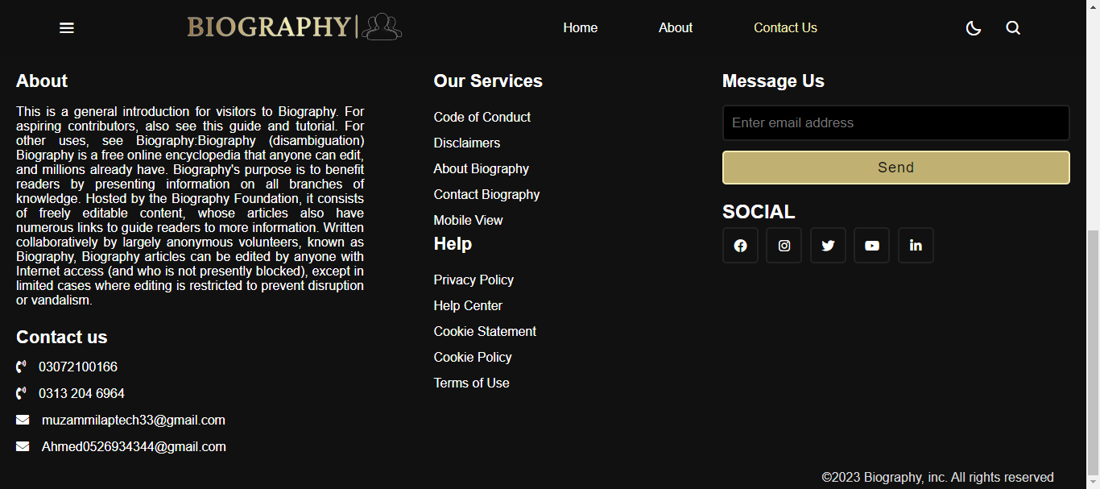

Our footer embodies connectivity and information accessibility. Stay connected with us across various social media platforms to keep abreast of the latest updates and breaking news. Explore our diverse news pages—Today in World, Business, Entertainment, and Sports—for a comprehensive view of global events. Navigate easily through our site map, granting quick access to essential sections like Home, About, Contact, and Sign-Up. For inquiries, feedback, or collaboration, reach out through the provided contact details. Thank you for choosing Biography as your reliable source of news and information.

© 2021 Biography- Your Trusted News Partner

**Task Sheet Review:**

|  |  |  |  |  |  |  |
| --- | --- | --- | --- | --- | --- | --- |
|  | | **Project Title** | **Date of Preparation of Activity Plan** | | | |
| No. | **Task** |  | Actual | Actual | Name | Status |
| Start date | Days |
| 1 | Navbar & Footer | Biography | 12/dec/23 | 2 | Ahmad | Complete |
| 2 | Home Page | Biography | 15/dec/23 | 3 | Ahmad | Complete |
| 3 | About US page | Biography | 18/dec/23 | 4 | Muzammil | Complete |
| 4 | Business page | Biography | 22/dec/23 | 2 | Shayan | Complete |
| 5 | Contact Us | Biography | 24/dec/23 | 3 | Shakir | Complete |
| 6 | Athletes | Biography | 27/dec/23 | 3 | Shayan | Complete |
| 7 | Singer | Biography | 30/dec/23 | 3 | Shakir | Complete |
| 8 | Biography page | Biography | 9/Jan/23 | 10 | Ahmad | Complete |
| 9 | Gallery page | Biography | 4/Jan/23 | 5 | Muzammil | Complete |
| 10 | Scientists page | Biography | 6/Jan/23 | 1 | Shakir | Complete |
| 11 | Movies page | Biography | 7/Jan/23 | 1 | Shayan | Complete |

**Summary:**

In collaboration with DNBC, a prominent news agency dedicated to delivering accurate and timely information, our team is embarking on an innovative project to craft a cutting-edge news platform. Proficient in HTML5, JSON, React JS, JavaScript, and content presentation, our team is excited about developing a dynamic and responsive website that redefines the news consumption experience. Our goal is to streamline access to information, offering a seamless and engaging platform for users. Ensuring compatibility across devices and browsers, including Chrome, IE, Firefox, and more, remains a top priority. This project marks a significant leap towards empowering audiences worldwide with a modern, informative, and easily accessible news hub. By embracing advanced technology and a user-centric approach, we aspire to establish DNBC as a leading authority in the realm of news dissemination.